
Social Media Analytics for Business in HealthCare
(Mayo Clinic vs Cleveland Clinic)

Final Assignment Submitted to

Dr. Esyin Chew

Department of Information Technology Management
By

Chidubem Ogechukwu Madubuko

ST20207148

December 2021

ABSTRACT

TABLE OF CONTENTS

LIST OF FIGURES

BIOGRAPHY
As Healthcare business analyst, I should collect and interpret data from a variety of sources to assist organisation in improving the quality of care, lowering the cost of care, and improving the patient experience. Responsible for presenting data to assist hospital executives and other in understanding the operational impact of the data. In addition, apply knowledge of data acquisition, managerial staff, analysation, and interpretation directly to healthcare data, providing actionable insights for physicians, clinical researchers, and others.

Introduction: Motivation or Rationale of the project
Business process improvement is a growing concern for healthcare organisations around the world, and it is a critical success factor. The goal is to improve organisational performance by redesigning processes or information systems to meet the fundamental needs of today's healthcare organisations (Rebuge & Ferreria, 2012). The emergence of social media resources in the form of social networking sites, blogs/microblogs, forums, question answering services, online communities, and encyclopaedias, which are frequently referred to collectively, denoted a shift from passive consumption to active creation of various types of content by Internet users (Kotov, 2015). In contrast to newswire articles, social media goes beyond providing facts and describing events to provide a plethora of information on public opinion on practically any topic, including healthcare.

Motivation
The Mayo Clinic have once again taken the top and runner-up spots in U.S. News & World Report's annual ranking of the best hospital in the country (Muoio, 2021). The list is meant to assist patients and clinicians in determining the best options for speciality care or specific treatments. What makes Mayo Clinic Different? It’s Safe, efficient care all in one place. “You will not have to wait weeks or even days for responses. If you have a morning test, your results will be available to your doctor that afternoon”. In fact, most initial visits to the Mayo Clinic last less than a week. We’ll make certain you receive the tailored attention and particular care you require so you can recuperate faster and return to the things and people you like the most (Mayo Clinic, n.d.).
This study will use a series of methods and visualization tools to analyse Mayo Clinic social data in detail. Find out what customers and employee reviews in the healthcare. Is the healthcare suitable? and present the data to assist hospital executives and other in understanding the operational impact of the data.

Design and discussion of data sources /tools/ APIs and justification of choice
The focus of this study is mostly on two points. First and foremost, this study will capture patient/customer feedback from Mayo Clinic. The study, on the other hand, will briefly assess employee feedback. Mayo Clinic will be analysed and discussed as the major purpose using visualisation techniques.
The study uses data sources from different social media. The term social media refers to a computer-based technology that facilitates the sharing of ideas, thoughts, and information through virtual networks and communities (Drury, 2021). The emergence of social media resources such as social networking sites, blogs/microblogs, forums, question answering services, online communities, and encyclopaedias, commonly referred to as Web 2.0, signalled a shift from passive consumption to active creation of various types of content by Internet users (Kotov, 2015). In this Study, three social media tools, Yelp, Twitter and Indeed, were selected as the main data sources. The Mayo Clinic patient/customer review can be found in Yelp (figure 1). Yelp, publish crowd-sourced reviews about businesses.

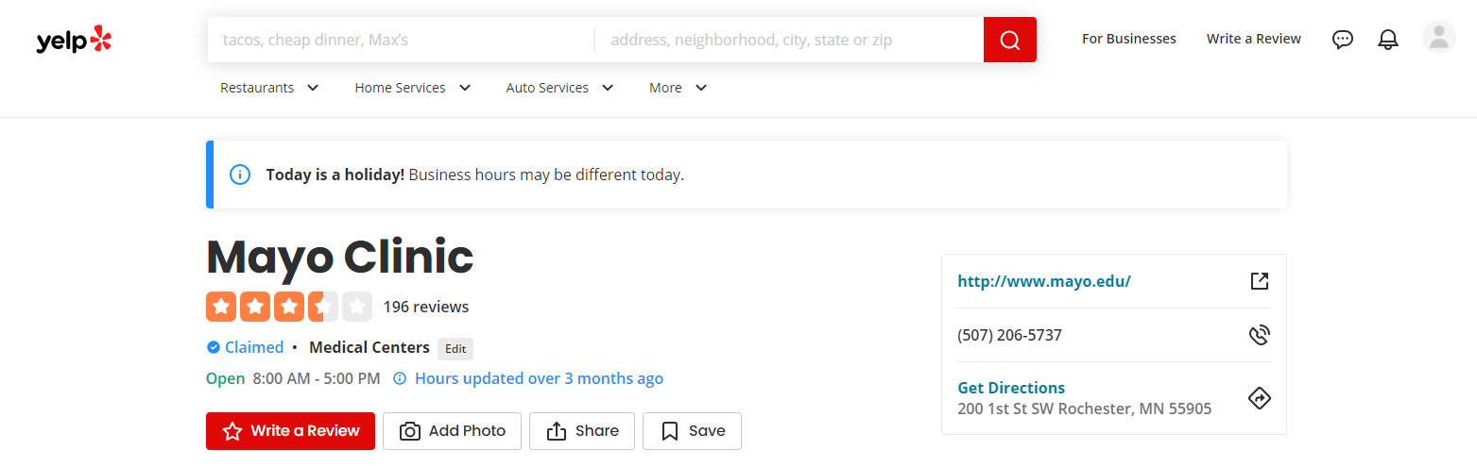
Figure 1: Mayo clinic Yelp account
(https://www.yelp.com/biz/mayo-clinic-rochester-12)

On the other hand, the employee feedback from Mayo clinic can be found in Indeed (figure 2). Indeed, Job listings are gathered from tens of thousands of websites, including job boards, staffing firms, trade associations, and company career pages.
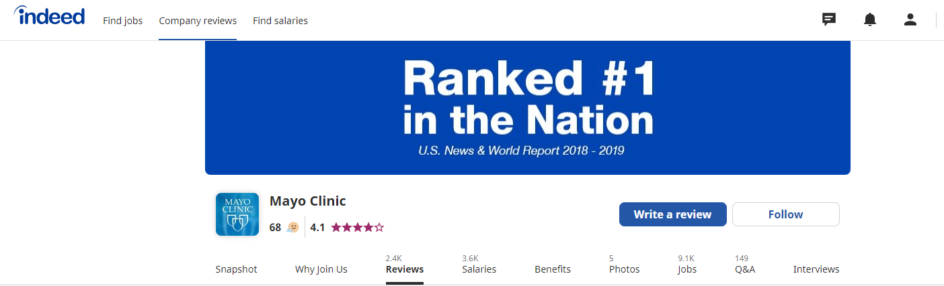
Figure 2: Mayo clinic Indeed account
(https://www.indeed.com/cmp/Mayo-Clinic)

Mayo Clinic official twitter followers has over 2 million people.
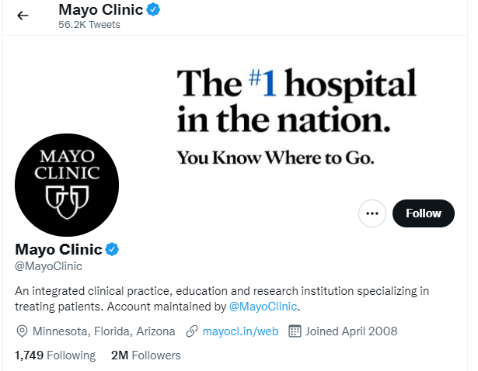
Figure 3: Mayo clinic Twitter account
(https://twitter.com/MayoClinic)

2.2 Tools and APIs
(Mester, 2019) quotes that “from data to information and from information to better decisions” there are typical six steps of data science project: Data collection, Data storage, Data cleaning, Data analysis, Data visualization, and Data-driven decision. (Figure 4)
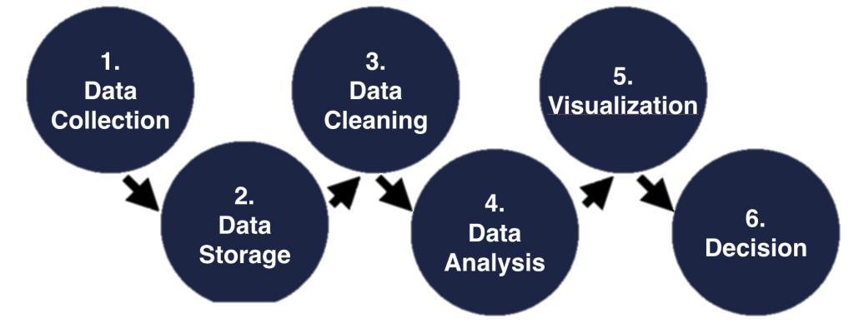
Figure 4: Steps for a Data science project (Mester, 2019)
On the basis of the above steps, the goal of this study is to use data from social media to analyse patient and workers at Mayo clinic. In the data collection stage, this study uses Octoparse for data mining, data storage, data cleaning and other operations. I tested some web scraping software like Data miner, Scrapy, Parsehub and other for research, but Octoparse has advantage. Octoparse is a modern web data extraction software with visual interface for both expert and beginner users to bulk extract information from websites (Octoparse, 2016). Octoparse is basically designed for non-coders to handle difficult web scraping, its guesses the desired data fields for users, saving you a lot of time and effort because you don’t have to manually pick data. This poses as a merit towards another web scraping tool. in addition, it automatically extracts content for practically any page and save it in a format of your choice as clean structured data. This benefit gives great convenience when it comes to data storage and data cleaning. In data processing, a range of APIs gives more and better data processing solutions. Octoparse can also create customized APIs from any data.

Octoparse deals with virtually all the website dynamic or static, it extracts text, image URLs, links, HTML, etc. Scrape category, a list/ grid of links with similar structure, contents loaded with Ajax, JavaScript etc. it crawls websites with indefinite scrolling, pagination, and extracts data behind login. (Figure 5)
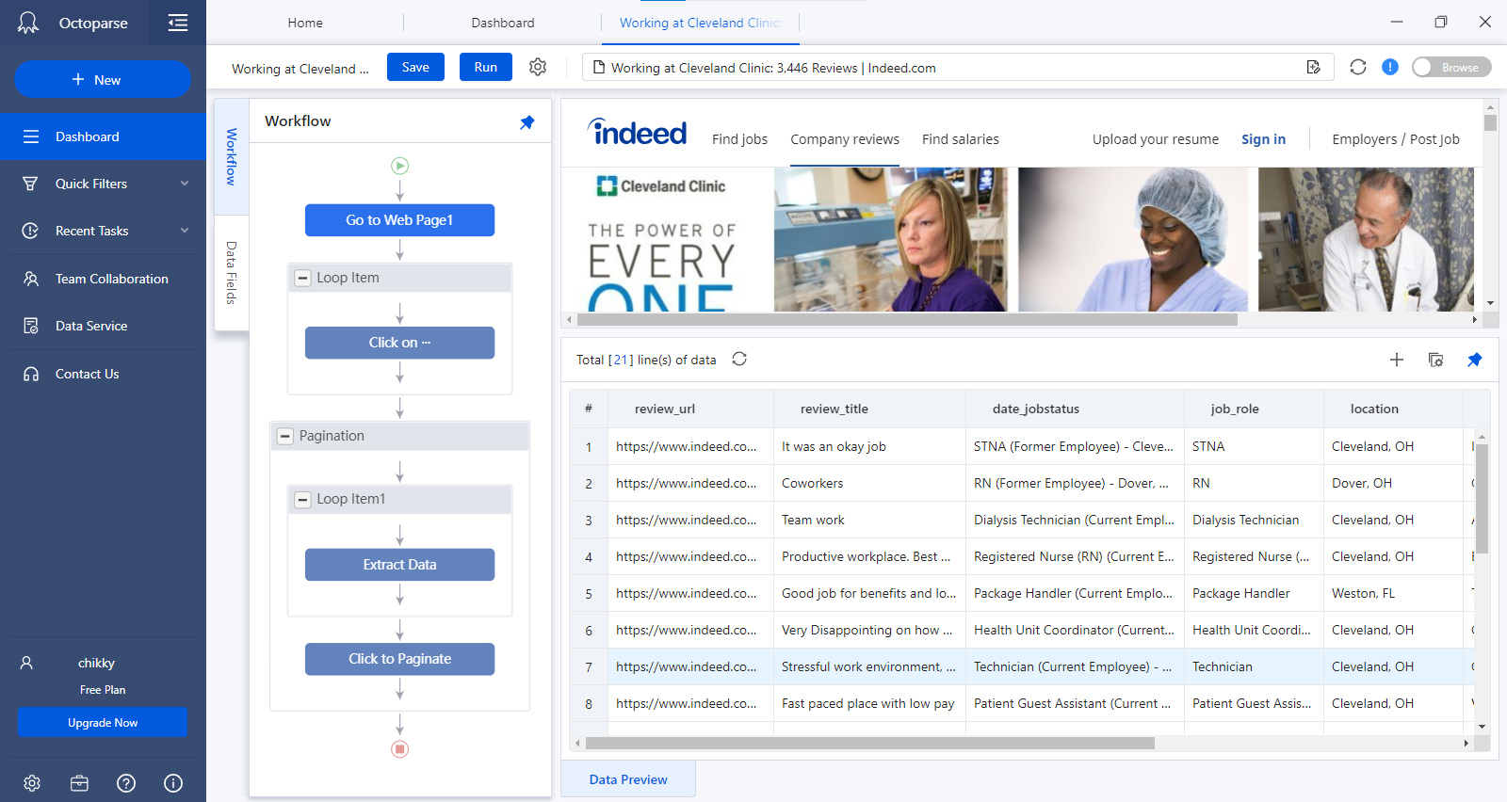
Figure 5: Octoparse example
The fourth step in the data science project, tableau, and sentiment analysis of twitter to visualize data. Tableau created most of the visual’s representations used in this study. Tableau is the trusted leader for analytics, and help people and organisations become more data-driven (Tableau, 2019). The advantage of tableau over traditional tools is that the visuals are faster, and the graphics generated are more appealing. As a result, study can concentrate on data rather than graph updating. Tableau also accommodates a wide range of data types. The data from social media is saved in an excel file in this scheme (.xsl file format). It’s built in visual best practises allow for unlimited visual data exploration without stopping the analysis flow (Figure 6). With accessible statistics, natural language, and smart data prep, its augmented analytics solutions let anybody from data scientist to business users uncover insights faster.
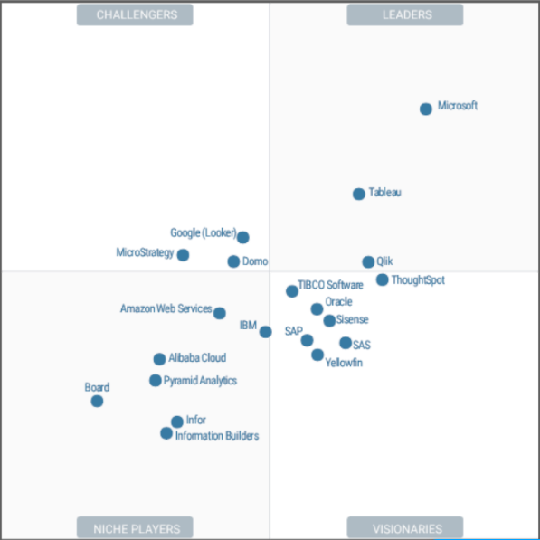
Figure 6: Tableau Global Visualisation (Dolley, 2021)

The study used Tableau and Sentiment Analysis Twitter, to analyse the data of Mayo clinic, first we use Octoparse to crawl down the text data in Twitter, then the sentiment analysis of the text data is carried out using Sentient Analysis tool and Python. Sentiment Analysis is textual mining that finds and extract subjective data in source material, assisting businesses in understanding the social sentiment of their brand product, or service while monitoring online conversations (Gupta, 2018). Both clinics topic text is analysed. We can evaluate the keyword and the degree of affection for each clinic using the analysis. The conclusion can go into more detail about how the organisations should improve their services in each clinic. The main purpose of using Python for Sentiment analysis is to identify whether the data is positive, negative, or neural. Sentiment Analysis tool will be used to preform analysis on textual data to help Mayo clinic and Cleveland clinic monitor brand and product sentiment in Customer and Employee’s feedback and understand their needs.

Key Results, Visualisation and Business Story Telling
Since the purpose of this research is to examine social media data for corporate narrative telling. As a result, the study substituted business story telling for the fifth and sixth steps in the data science project. This part will analyse and visualize data acquired using various techniques, as well as discuss the main findings in depth.

